Neural Networks for Voice Recognition and Visual Representation of Sound Using Audio Files

Seda Gulcin Colasan
CCT College Dublin
Ireland, Dublin
2023010@student.cct.ie

Abstract—This article aims to explore the utilization of neural networks for speech recognition and sound visualization through the processing and analysis of audio files. The processing and interpretation of sound data hold significant potential in various domains of modern technology.
Keywords—Deep Learning, Sound Analysis, Neural Networks, Sound Visualization, Neural Networks Models

Introduction
In today’s world, the analysis and processing of audio files are of critical importance in a wide range of applications. Voice assistants, speech recognition, music classification, and more heavily rely on extracting valuable insights from audio data. In this article, we eill explore how neural networks can be employed to process audio files, perform voice recognition, and generate visual representations of sound.
In this section of the article, we will focus on the significance of analyzing and processing audio data in today’s context. The diversity of information contained within audio files enables the development of sound-based applications. Within this context, we will expalin the impact and advanteges of neural networks in processing audio data.
Subsequently, we will delve into the step-by-step- process of using audio files for voice recognition and creating visual representations of sound. This process will encompass preprocessing audio data, designing and training a neural network model, and how audio data can be utilized as a visual representation.
In conclusion, this article aims to provide a guide for researchers, audio engineers, and artificial intelligence applitication developers interested in voice intelligence application developers interested in voice recognition and visual representation of sound using audio files. It will serve as a fundamental starting point for readers seekin to learn more about audio data analysis and the use of neural networks.
How the processing of audio files and the use of neural networks can facilitate speech recognition and sound visualization. In which areas can the processing of sound data and the use of neural networks provide advantages?
The primary objective of this article is to assess the effectiveness of processing audio files and employing neural networks for speech recognition and sound visualization. We explore the methods through which sound data can be processed using neural networks.

what is the Audio data?

Sound and Sound Analysis
Processing Audio Data in the Field of Data Science Sound is a significant sensory experience where humans communicate, create and experience music, and other auditory content. However, the processing and analysis of audio data are essential to access crucial insights in this field. Sound analysis is a discipline that investigates in-depth examinations of sound data and explores how this data can be employed, especially in the realms of data science and artificial intelligence.

Processing Audio Data
Sound data is comprised of a series of sound waves and generally includes a multitude of sampled data points within a given timeframe, often occurring in the order of thousands per second. Processing these sound waves involves the procedures of organizing, cleaning, normalizing, encoding, and more. These steps constitute fundamental parts of the data processing process.

Sound Analysis
Sound analysis aims to examine sound data more comprehensively and uncover the information it contains. These analyses can be used for applications such as speech recognition, music classification, sound effects creation, and many more. Sound analysis may include extracting features such as spectrograms, mel-frequency cepstral coefficients (MFCCs), and other characteristics. These features can later be used as inputs for data science models.
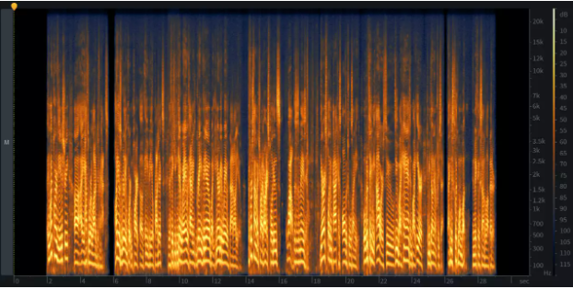
Figure 1: An example of a spectrogram

The Relationship between Sound Data and Data Science
Sound data plays a significant role in the fields of data science and artificial intelligence. Speech recognition models, natural language processing projects, automatic speech recognition systems, and more rely on techniques that process and analyze sound data. In this context, sound analysis bridges the gap between data science and sound data, facilitating the transformation of sound data into meaningful information.
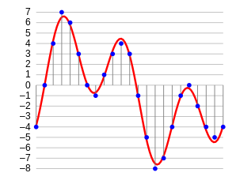
Figure 2: Sampling of audio data
One of the fundamental steps in processing sound data is to convert this data into a format understandable by a machine. During this process, samples of sound data are taken at specific time intervals. For example, when dealing with a 2-second audio file, we sample data points at regular time intervals, typically extracting data every half a second. This process is referred to as "sampling sound data," and the rate at which data is sampled is known as the "sampling rate."
Figure 3 : three unique values in frequency domain.
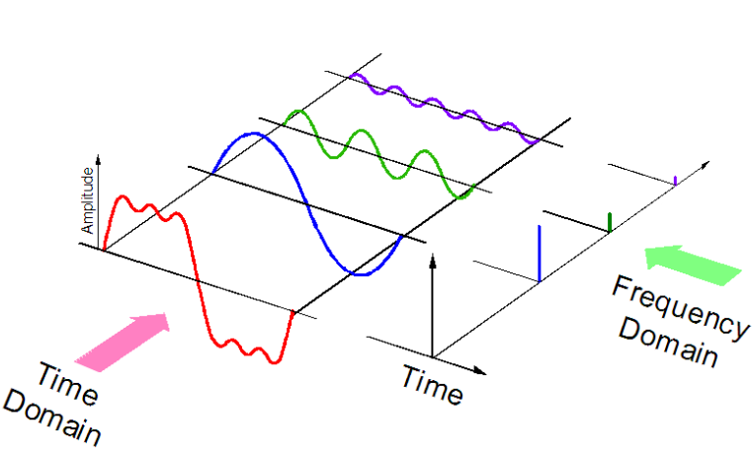
When processing sound data, it is crucial for the sampling rate to be as high as possible to represent the data in higher resolution. This entails the collection of a greater number of data points, but it also allows for a more detailed representation of sound data.
Alternatively, sound data can be transformed into a different data representation field known as the "frequency domain." When sampling sound data, it may be necessary to acquire more data points and maintain a high sampling rate. However, when we represent sound data in the frequency domain, it requires less computational space. This enables the processing of sound data with reduced storage and computational resources.
Sampling sound data and transforming it into the frequency domain represent two different approaches in the processing of sound data. The choice of method depends on the data processing requirements and the desired outcomes. When working with sound data, it is essential to consider the advantages and disadvantages of these two approaches.

Neural networks
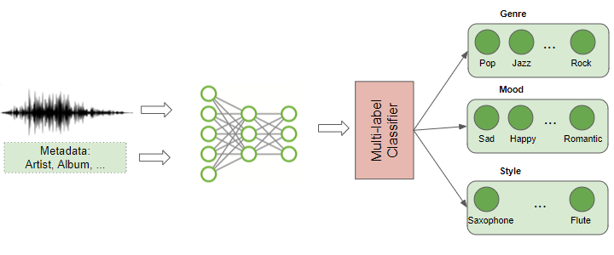
Inspired by biological neural systems, are artificial intelligence models. These artificial neural networks can be successfully employed in a range of tasks, such as learning, classification, prediction, and pattern recognition. When working with audio files, neural networks can be used for speech recognition and visualizing sound.
Figure 4 : Audio deep learning models

Which Types of Neural Networks Can We Use?
- Recurrent Neural Networks (RNNs):
RNNs are useful for processing time-varying data, and they are particularly preferred in applications like speech recognition.
- Convolutional Neural Networks (CNNs):
Typically used for processing visual data, CNNs can also be used to analyze sound spectrograms and process audio files.
Both are effective in specific tasks and data types, but they have distinct characteristics.

Differences:

Data Processing Approach:

RNN: RNNs are designed to handle data with dependencies, such as time series and sequential data. They have the ability to remember information from previous time steps.

CNN: CNNs are designed for processing raw data like visual images, focusing on learning features at different positions.

Architecture:

RNN: RNNs have a loop structure that allows them to incorporate information from previous time steps into current computations.

CNN: CNNs incorporate specialized architectural components such as feature extraction layers and subsampling layers

Independence:

RNN: RNNs are used to solve problems involving temporal dependencies but require more computational power and data.

CNN: CNNs are used to extract spatial features from images and are less dependent on sequential data.

Similarities:

Deep Learning:

Both RNNs and CNNs are categorized as deep learning models, and they are used to learn complex features from large datasets.
- Feature Extraction:
Both neural network types are used for feature extraction and learning important features from data. RNNs can extract features from time series data, while CNNs can extract spatial features from images.
- Feature Extraction:
Both neural network types are used for feature extraction and learning important features from data. RNNs can extract features from time series data, while CNNs can extract spatial features from images.
- Computer Vision:
Both RNNs and CNNs are effective in computer vision applications. CNNs are widely used for image classification, object recognition, and facial recognition, while RNNs are used for tasks like video understanding.

In conclusion, RNNs and CNNs are neural network types optimized for different data types and tasks.

Examples of Where RNN and CNN Are Used
- Recurrent Neural Networks (RNN) Examples

- Text and Language Processing:
RNNs are used to work with text data and perform text-based tasks. Examples include language modeling, text classification, text-to-speech synthesis, and speech-to-text translation.

- Time Series and Financial Forecasting:
RNNs are employed to process time series data and predict financial markets. They can be used for tasks such as stock price prediction, weather forecasting, or energy consumption forecasting.

- Music and Art:
RNNs are used for music composition, generating artistic content (e.g., images or text), and similar creative applications. For instance, a music composition RNN can create new music compositions.

- Medical and Healthcare:
RNNs are used for disease diagnosis, biomedical data analysis, patient monitoring, and diagnosing neurological diseases.

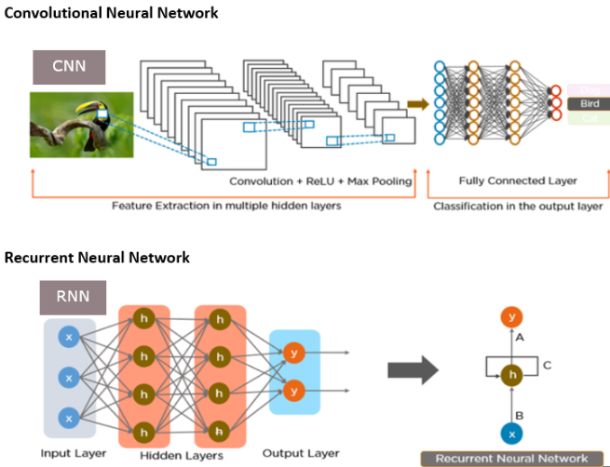
This should give you an overview of where RNN and CNN are commonly used and their respective applications.
Figure 5: The Main Difference between RNN and CNN

- Examples of Convolutional Neural Networks (CNN):

Image Classification:

CNNs are used for classifying images, for instance, tasks that involve recognizing whether an image contains objects like a dog, cat, or car.

- Object Detection:
CNNs are employed for classifying objects and detecting their locations. This is widely used in applications such as autonomous vehicles, security cameras, and video surveillance.

Face Recognition:

CNNs are used for face recognition and facial analysis. This application is commonly used in security systems and social media platforms.

- Medical Imaging:
In medical imaging applications, CNNs are used to analyze X-rays, MR images, and other medical images. They can be used, for example, for cancer diagnosis or disease detection.

Video Analysis:

CNNs are used for video surveillance and video content analysis. This is important for applications like traffic monitoring, motion detection, and similar tasks.

Which Methods Can We Use?
- Feature Extraction: Before processing audio data, it's essential to extract features. Audio features like Mel-Frequency Cepstral Coefficients (MFCCs), spectrograms, or feature vectors are used to represent audio data.
- Training and Model Selection: Selecting a well-trained neural network model and training it on audio data is crucial. We might prefer a model like DNN, LSTM, or CNN depending on our project's needs.
- Data Augmentation: If we have limited data, using data augmentation techniques can help train our model more effectively. Diversifying and expanding audio files can assist in achieving better performance.
- Hyperparameter Tuning: We can optimize our model's performance by adjusting hyperparameters like the learning rate, the number of epochs, mini-batch size, and others.
- Audio Visualization: To visually represent audio files, we can use techniques like spectrograms or waveform visualization.
These methods and neural networks are fundamental tools for speech recognition and sound visualization. The choice of method and neural network type depends on our project's requirements and our dataset.
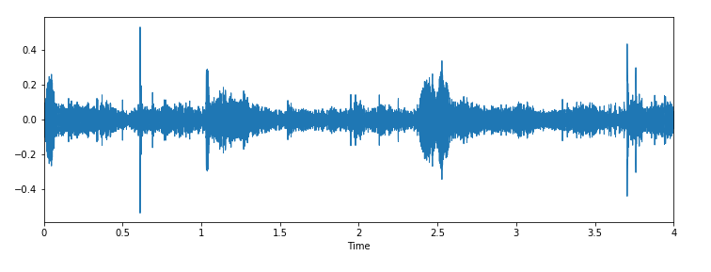
Figure 6: Sound file of the band Jackhammer

Some Common Mistakes
Common mistakes can be made when processing audio files, especially in complex tasks such as voice recognition and audio visualization with neural networks. Here are examples of such errors:
- Insufficient Data: The size and diversity of our dataset significantly affect our model's performance. Using too few or a single type of audio data can negatively impact our model's ability to generalize.
- Overfitting: Overfitting to the training data can lead to our model misclassifying new audio files. This happens when the model becomes too tailored to the training data.
- Incorrect Labeling: If our dataset is incorrectly labeled, it can mislead our model. For instance, audio files labeled with the wrong class can lead our model to produce inaccurate results.
- Data Imbalance: The unequal distribution of audio files across different classes can lead our model to better learn some classes over others. This can result in incorrect results due to unbalanced class distributions.
- Hyperparameter Settings: Failing to properly adjust hyperparameters during training can negatively affect our model's performance. Incorrect settings for parameters like learning rate or the number of epochs can lead to slow learning or overfitting.
- Missing Data: Neglecting to process missing or corrupted audio files can cause our model to misinterpret data.
- Proper Feature Selection: The failure to extract appropriate features from audio data can lead to our model misinterpreting data. Choosing the right features is essential.
- Wrong Model Selection: Choosing the right neural network model for speech recognition and audio visualization is crucial. Using the wrong model can affect performance negatively.
- Inadequate Data Augmentation: Failing to utilize data augmentation techniques or using them inadequately can reduce our model's performance, especially when working with limited data..
To prevent these errors, it's essential to implement a robust data collection and cleaning process, select the appropriate model, set the right hyperparameters, and take proper training measures.

model buıldıng and settıng
When we look at an audio file, we see a fluctuation, like in the image (Figure6.) below. In this form, an audio file does not mean anything to the CNN algorithm or the deep learning algorithm. We will extract the attribute memory of this audio file. We will use a different library for this; we will create the feature map using this library, and we will use the data we obtain on CNN.

Preparation for the Model
We used TensorFlow here, and we also use Keras along with it.
First, what is TensorFlow? And what does it do? Let's take a brief look:
TersorFlow is a powerful tool used to develop complex data analysis, deep learning, and artificial intelligence applications. With TersorFlow, we can provide data flow graphing, deep learning, interoperability with other platforms (CPU, GPU), training graphic models, and speed and efficiency.
We will use TensorFlow here, or rather we will use Keras, which is under TensorFlow. First, we need to check the version because TensorFlow must be at least 2.3. Because in order to extract the attributes of the audio files, the librosa library wants it to be above version 2.3. Our version is 2.9.
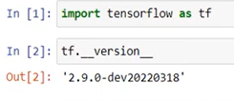
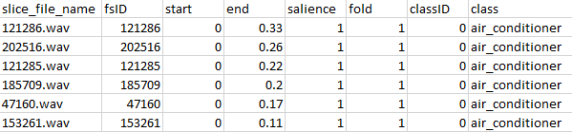
Figure 7: Version Control
Figure 8: UrbanSound8K.csv

If TensorFlow is not installed on my computer, we need to install it first so that we can work on our file and make the necessary analysis.
Of course, we don't just use TenForFlow. Other libraries we need are also available. We install these, respectively; like Librosa, OS, and tqdm.
Libros is the library that makes attributes, we need to add this because it is an important library that we can use for audio analysis and extracting the attributes of audio files.
It makes it easy to read and write audio files with the OS, and the importance of adding the Tqdm library is to get a nice view when we finish, and it makes it easier to monitor the progress of time-consuming tasks.
We need to import the necessary libraries to work on deep learning tasks with TensorFlow and Keras. Some of them and their functions are briefly;
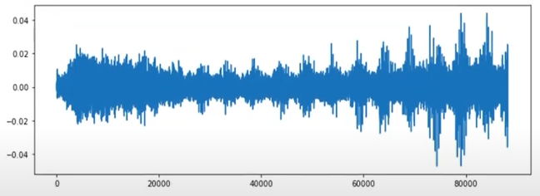
We will convert to numeric values using one-hot encoding, LabelEncoder using categorical, important to create a sequential model with keras.models and we will use Adam as the optimization algorithm. While the Dense layer creates a fully connected layer, Dropout is used to reduce the problem of overfitting. Activation layer adds a specific activation function and Flatten layer flattens the data.
Figure 10: 114113.wav audio visualize output

Dataset
The dataset we will use here is a ready dataset [1]. When we enter the site, we are greeted with a Google form that we need to fill in first. This series is free and provides approximately 8000 audio files when we download it. When we download our dataset, we see 10 folders as fold1, fold2. There are different audio files in them. These are as follows;
- Air_conditioner
- Car_horn
- Children_playing
- Dog_bark
- Drilling
- Engine_idling
- Gun_shot
- Jackhammer
- Siren
- Street_music
Data regarding these are kept in metadata. The name of our dataset is urbansound8K. This is a csv file, folders are written respectively. It states which sound file belongs to which category, which file it is in, the number of seconds the sound starts and ends, and whether the sound is in the background or in the foreground.

Our CSV file is important because we will get the data from here and we will get which data belongs to which class and which category.
We have come this far and now that we have added our dataset to our project, we can call a random audio file.
As you can see below, we shot the 114113.waw audio file. What we said about the audio file is that an audio file has fluctuations. Now let's see what this involves. It contains list type data.
Figure 9: 114113.wav audio file output
Of course, the data here is meaningless data for deep learning. Currently, this data means nothing to us and has no features. When we look at it briefly, there is meaningless data. If we want to visualize this, we get the image below. There is data here that is extremely meaningless to us and extremely meaningless to the CNN algorithm.

How Do We Extract Features?
How do I create the feature map for this?
Here, there is a function called mfccs with the data as a parameter and it determines how many features will be extracted. The standard for this is normally 20, but here we set it as 40. From where? Because it works better on the model and achieves better learning results. We can increase or decrease this. When we looked at the shape, we found 40,173. If you ask what the 40 is here, it is the 40 we give. We divided it into 40 parts here.
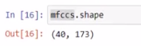
Figure 11: 114113.wav shape output
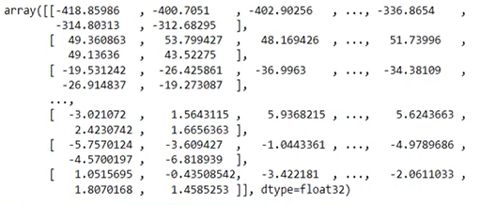
In the Figure 12 you see below; Here it has been transformed into a numpy array, but what we see in figure9 is raw data that has not been processed and its attributes have not been removed. Here, it now represents meaningful data for the CNN with its processed features extracted.
Figure 12: Data output converted to numpy array
Now we will pull the data from all the folders here. We will also pull metadata. As you can see in the image below, each folder has its name, which folder it is in, and its classID. We created a function to perform the Mfccs operation on these folders collectively via librosa. We have created a list here and will add the incoming data to the list. We pull all the data from the folders in this way.
Here we have extracted the attribute map of the data in this entire folder, and this process takes a few minutes. Afterwards, we will convert the data into a dataframe, perform a few operations on it, apply it to the CNN model and see the result.
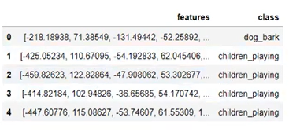
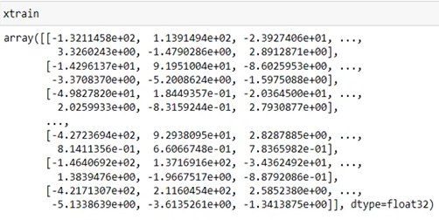
When the feature extraction process of our data is completed, we start converting it into dataframes. We create two separate groups: "features" and "class". The features here are the values obtained here, and they are taken from extracted_features. The values we obtained here and the classes they belong to, which we will train, are displayed in the Figure13 below.
Figure 13: Features and Class
Figure 15: xtrain output

Figure13. As we see, in our first 5 data, we see dog_bark and children_playing in the class column. Now we will create my dependent and independent variables. There are more than 8000 data here and the shape consists of 40 shapes.
If you remember what these 40 are, we wanted to create and process feature maps in 40 different ways in the feature memory. Therefore, it is not from here, we could do it as 10, we could do it as 20, we could do it as 50.
The more we increase the number of these, the more detailed the feature will appear on the model and the more successful the learning process will be in deep learning.
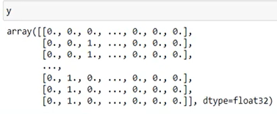
Now here we will convert our categorical data into 0s and 1s.
Figure 14: Categorical data into 0 and 1

When we look at Y, it continues as 0,0,0. Now, when we look at the first data in category Y here, if this data belongs to the dog, it goes as 0,0,0,1,0,0. Whichever row our data matches with 1, this data belongs to it. In this way, it turns into 0s and 1s with the labelencoder code. Because we can say why car_horns or children_playing strings do not have any effect or operation on our dataset, they do not mean anything.

Deep Learning
Now let's divide our dataset into two as train and test. While doing this, we will use 80% of the data as train and 20% will be our test data.
Now let's pull random data. If we look at xtrain, we see that it is given with its attributes removed. Now that I have 10 categories, I can create a variable and create my layers for deep learning.

I am creating my layers. Here we created the Artificial Neural Network model from 3 layers. I want to create my model from 3 different hidden layers and get 10 different outputs. Normally, the outputs would generally be 2, but since we have a data type consisting of 10 different categories, we divided the output type into 10 different data types by softmaxing.

Now we can view the properties of the model.

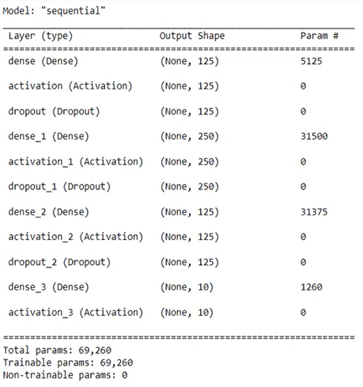
Figure 16: features of the model
Figure 19: prediction on model
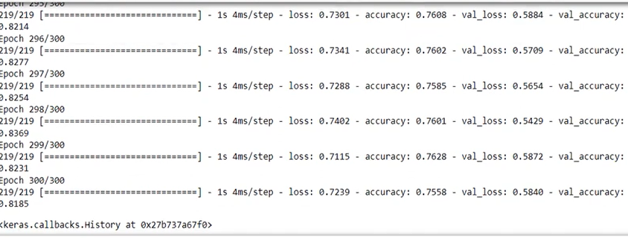
As seen in Figure 16, we see how it is processed. Now I compile it and used Adam as the optimizer. To ensure high speed and accuracy. I set my Epochscount to 300. If we want, we can increase this number to make learning take longer and achieve more successful results. When we fit our model, we started the learning prompt, which may take 2 or 3 seconds, maybe a little longer, for each epoch value. When we look here, we can see that the accuracy value starts from 0.30 or even 0.10. We can say that it will gradually reach 80%.
Figure 17: model learning

Now, when we look at the validation value here, we find it to be 0.81 and we understand that it has completed the learning process with a rate of 81%. Now we take our data and predict the application.
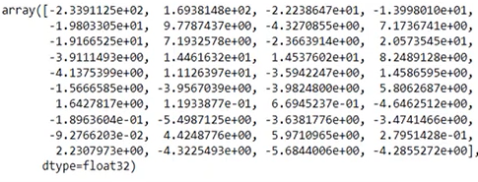
Now we take a random file and let's look at our features. We will scale these and display the result below.
Figure 18: features output of any audio file

We make predictions on the model in the Figure19. below. Using these features as a model, we predict which class or category the sound belongs to, and then we find the one with the highest probability.
These predictions are used to evaluate how well the model works or to understand which class the input sound belongs to.

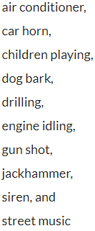
Let's look at the result, it is as shown in the image below, here we need to check whichever ratio is higher. We need to check it by counting 0,1,2,3 based on the Figure20. below. Now the highest here is 6th. Now, we have created our categories according to their order so that these are meaningful data for us.

Figure 20: categories list

Now we need the index number of the index with the highest estimate, or rather the index number of the value.
Figure 21: output of index number

Let's see what the result is. It tells us it's a Jackhammer. Let's visualize this. Here we create an if loop, if the name in the categories belongs to the photo, we say, respectively.
We can even add the sound of this and listen to it. Is it really Jackhammer?
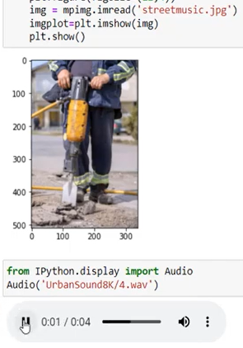
Figure 21: jackhammer image and sound output
As you can see, we have obtained the result with artificial intelligence by processing sounds in different categories. The more we try, the more different results we can get.

Conclusion and Future

- Voice Assistants and Speech Recognition:
Neural networks applied to audio files are fundamental for voice assistants (e.g., Siri, Google Assistant, Alexa) and speech recognition systems. In the future, more intelligent and accurate voice assistants will provide faster and easier access to information for users.

- Voice Biometrics:
Audio files capture unique vocal features of individuals. Voice biometrics can be used for security applications. In the future, it may become more widely used for identity verification and security systems.

- Health and Medicine:
Sound analysis has numerous applications in healthcare and medicine. Changes in voice can provide insights into a person's health. In the future, using audio files, early diagnosis of diseases and monitoring of treatment processes may become more effective.
- Education and Learning:
Speech-driven educational applications can assist students in learning new languages and subjects. Audiobooks and speech recognition systems can provide increased access to education.

- Audio Analytics and Content Discovery:
Neural networks processing audio data make it easier to perform analytics on large volumes of audio content. This can be used for content discovery and analytics in various fields, from the music industry to marketing campaigns.

- Art and Creativity:
Audio data offers new possibilities in art and creativity. Visualizing and transforming sound can lead to the creation of new sound effects and artistic expressions.

- Sound Engineering:
Sound visualization and analysis tools are valuable for music production and sound engineering. Sound engineers can use these tools to better understand and process audio data.

- Emotion Analysis and Emotional Intelligence: Sound analysis can be used to detect a speaker's emotional state. This has potential applications in marketing, human resources, and emotional intelligence development.

- Translation and Transcription:
Voice recognition technologies can automatically translate and transcribe speeches in different languages. This can break down language barriers and facilitate communication.

- Night Vision and Autonomous Vehicles:
Sound-based technologies can enhance night vision and support autonomous vehicles. Auditory alerts can warn drivers of potential dangers and improve safety.

References

[1] | C. J. a. J. P. B. J. Salamon, "UrbanSound8K," 10 2014. [Online]. Available: https://urbansounddataset.weebly.com/download-urbansound.html.
[2] | "freesound," Pixelshell., [Online]. Available: https://freesound.org/.
[3] | J. Korstanje, "towardsdatascience," 14 10 2021. [Online]. Available: https://towardsdatascience.com/machine-learning-on-sound-and-audio-data-3ae03bcf5095.
[4] | J. MicMico, "plainenglish," 19 03 2023. [Online]. Available: https://ai.plainenglish.io/revolutionizing-audio-engineering-separating-tracs-using-python-and-neural-networks-966aeb7243df.
[5] | H. Purwins∗, "Deep Learning for Audio Signal Processing," Deep Learning for Audio Signal Processing, pp. 2-9, 2 05 2019.
[6] | J. Shaikh, "analyticsvidhya," Analytics Vidhya, 27 08 2021. [Online]. Available: https://www.analyticsvidhya.com/blog/2017/08/audio-voice-processing-deep-learning/.
[7] | "analyticsvidhya," 05 08 2017. [Online]. Available: https://datahack.analyticsvidhya.com/contest/practice-problem-urban-sound-classification/.
[8] | VINCENZOOO, "kaggle," 2019. [Online]. Available: https://www.kaggle.com/code/vincee/intel-image-classification-cnn-keras.
[9] | A. ŞEKER, "Derin Öğrenme Yöntemleri ve Uygulamaları Hakkında Bir İnceleme," Derin Öğrenme Yöntemleri ve Uygulamaları Hakkında Bir İnceleme, pp. 2-9, 17 09 2017.
[10] | [Online]. Available: https://docs.google.com/presentation/d/1zzgNu_HbKL2iPkHS8-qhtDV20QfWt9lC3ZwPVZo8Rw0/pub?start=false&loop=false&delayms=3000&pli=1&slide=id.g5a7a9806e_0_84.
[11] | N. Ashutosh Tripathi Artificial Intelligence, "Data Science Duniya," 12 07 2021. [Online]. Available: https://ashutoshtripathi.com/2021/07/12/the-main-difference-between-rnn-vs-cnn-nlp/.

